- The density ρ and the pressure p of a gas are related by the expression

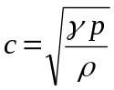,

where c and γ are constants.

- (i) Determine the base units of density ρ.

base units: ………………………….

(ii) Show that the base units of pressure p are kg m⁻¹ s⁻².

[3]

- Given that the constant γ has no unit, determine the unit of c.

unit: ………………………...
[2]

- Using your answer in (b), suggest what quantity may be represented by the symbol c.

………………………………………………………………………………………
[1]

- A stuntman on a motorcycle plans to ride up a ramp in order to jump over a number of cars, as illustrated in Fig. 1. His take off speed is 14 ms⁻¹.

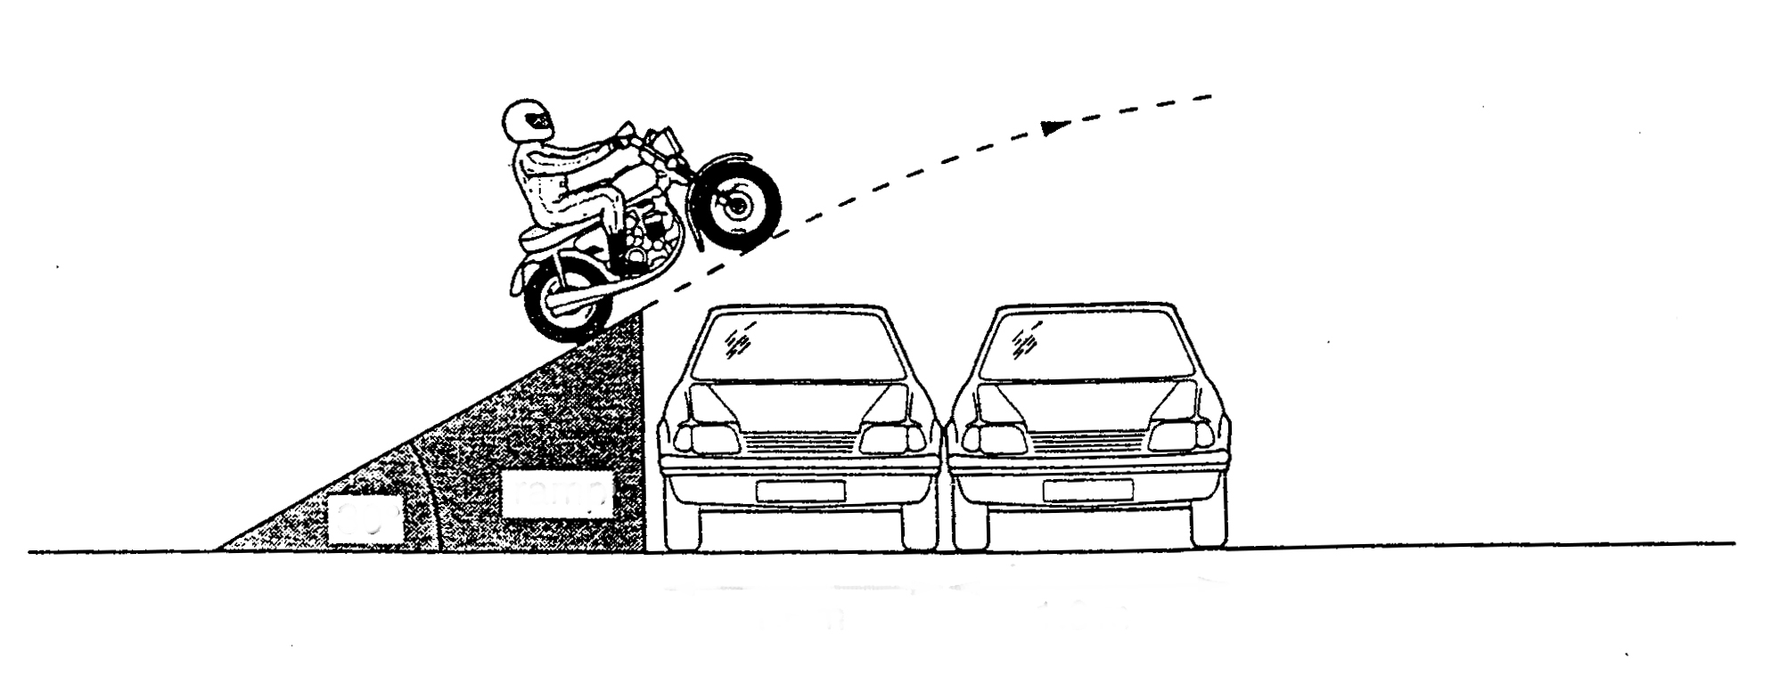
1.6 m
1.6 m
30°
ramp
Fig 1

- Calculate the time interval between leaving the end of the ramp and reaching maximum height.

time interval = ………………….. s [2]

- The cars are each of width 1.6 m and the same height as the ramp. Estimate the maximum number of cars which the motorcyclist can jump for the take-off speed of 14 ms⁻¹

number = …………………..
[3]

3. (a) (i) Define linear momentum

……………………………………………………………………………….

(ii) Define force in terms of momentum.

……………………………………………………………………………….

(iii) Show that this definition leads to the equation F = m x a.

[5]

(b) In a gas a hydrogen molecule, mass 2.00 u and velocity 1.88 x 10³ m s⁻¹,
collides elastically and head on with an oxygen molecule, mass 32.0 u and
velocity 405 ms⁻¹, as illustrated in Fig. 2.

hydrogen molecule
oxygen molecule

1.88 x 10³ m s⁻¹
405 m s⁻¹

mass 2.00 u
mass 32.0 u

Fig. 2

- determine the velocity of separation of the two molecules after the collision,

velocity of separation = …………………... m s⁻¹
- apply the law of conservation of momentum to the collision,

- determine the velocity of both the molecules after the collision

[6]

4. (a) By using the equations of motion, show that the kinetic energy E_{k} of an object
of mass m traveling with speed v is given by

E_{k} = ½ mv²

[3]

(b) A cyclist, together with his bicycle, has a total mass of 90 kg and is traveling
with a constant speed of 15 m s⁻¹ on a flat road at A, as illustrated in Fig. 3.
He then goes down a small slope to B so descending 4.0 m.
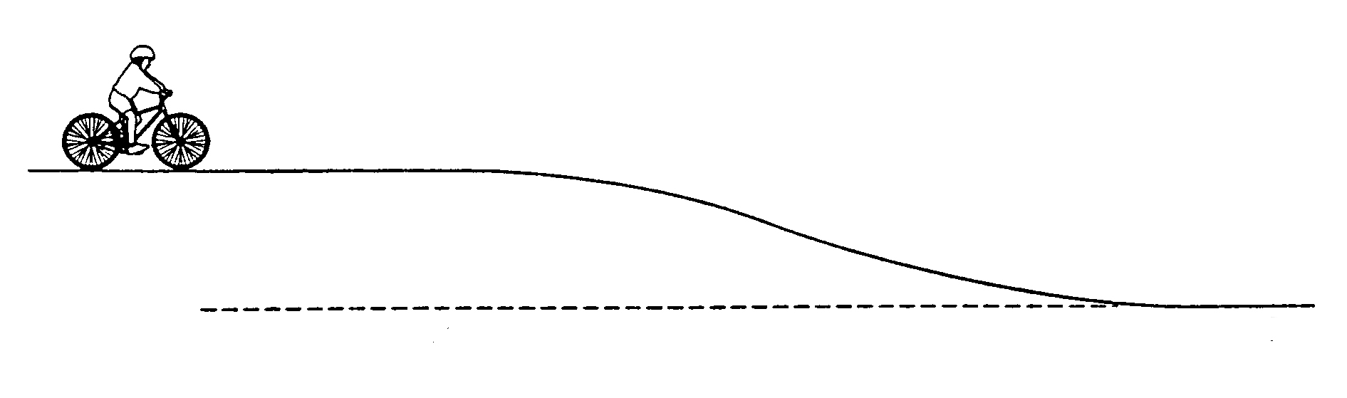
A
B
4.0 m
Fig. 3
Calculate

- the kinetic energy at A,

kinetic energy = …………………..J

- the loss of potential energy between A and B,

loss of potential energy = …………………J

- the speed at B, assuming that all the lost potential energy is transformed into kinetic energy of the cyclist and bicycle.

speed = …………….. ms⁻¹
[5]

- A catapult is made of rubber cord of total unstretched length 150 mm and of square cross-section of side 1.5 mm. The cord is stretched to a length of 180 mm and then released to propel a mass of 6.0 g horizontally. The Young modulus for rubber is 2.0 x 10⁷ Pa. Calculate

(i) the tension in the stretched cord,

tension =………………..N
[2]

(ii) the energy stored,

energy =…………………J
[2]

(iii) the speed of the mass leaving the catapult.

speed =……………..…ms⁻¹
[2]

State two assumptions made in your calculations.
………………………………………………………………………………………………
………………………………………………………………………………………………
…………………………………………………………………………………………[2]
- (a) Distinguish between longitudinal and transverse progressive waves.
…………………………………………………………………………………………………………………………………………………………………………………………………………………………………………………………………………………………………………………………………………………………………………………………………………………………………………………………………………………………………………………………………………………………………………………………...[2]

(b) Fig. 1.1 shows the variation with time t of p, the excess pressure at a point in a progressive sinusoidal wave in air. The speed of the wave is 340ms⁻¹.
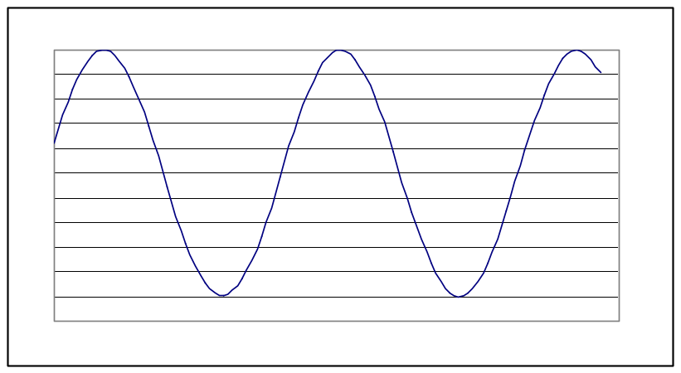
350
770
1190
t/μs
P/Pa
0.5
0.25
-0.5

Determine
(i) the amplitude,

amplitude = ……………..Pa
(ii) the frequency,

frequency = ……………Hz
(iii) the wavelength.

wavelength =……………..m
[4]
- (a) Define the terms potential difference and resistance.
…………………………………………………………………………………………………………………………………………………………………………………………………………………………………………………………………………………………………………………………………………………………………………………………………………………………………………………………………………………………...[2]

(b) Two sets of coloured lamps are designed for use with a 240V supply. Both sets have 12 lamps. In one set the lamps are in parallel and in series in the other. In each case the total power is 60W. For a single lamp in the set connected in series, calculate

(i) the current,

current = …………A
(ii) the potential difference,

potential difference = ..…………V
(iii) the resistance

resistance=……………….....Ω
[3]

Calculate the same three quantities for a lamp in the set which is connected in parallel. [3]

- (a) Explain what is meant by the term radioactivity.
…………………………………………………………………………………………..
…………………………………………………………………………………………..
……………………………………………………………………………………….[2]

(b) Distinguish between α-particles, β-particles and γ-ray photons, making reference, wherever appropriate to charge, ionisation and penetration.

[6]
[End of questions]

